
©2025 Personal Transition Guidance LLC & Courageous Women Publications™
Client Services Agreement
February 2025
PEGGYLEE HANSON

GENERAL TERMS
Project Name: | Courage Under Siege, 2025 Volume 8 Edition
Date of project: | Summer-Winter 2025
Scope of project: | Create and produce eBook and print versions for Amazon.com, and audiobook via Audible.com, at minimum. At most, eBook distribution

BOOK FORMAT
FRONT MATTER SECTIONS | PARTY RESPONSIBLE
- Cover (Front and Back)  - Copyright and Publishing Info  - Table of Contents  - Introduction  - Testimonials (if applicable)  - Acknowledgments  - Foreword (by a respected colleague of PeggyLee’s) | PeggyLee
BODY/CHAPTER SECTIONS | PARTY RESPONSIBLE
10 Chapters – approximately 30,000-45,000 words in total, 3,000-4,500 each | Individual Authors
BACK SECTIONS | PARTY RESPONSIBLE
- Epilogue/Synopsis (if applicable)  - About the Publisher (authors will have bios displayed at end of chapter) | PeggyLee / Authors

BOOK PRODUCTION, PUBLISHING PHASES, TIMELINE (example)
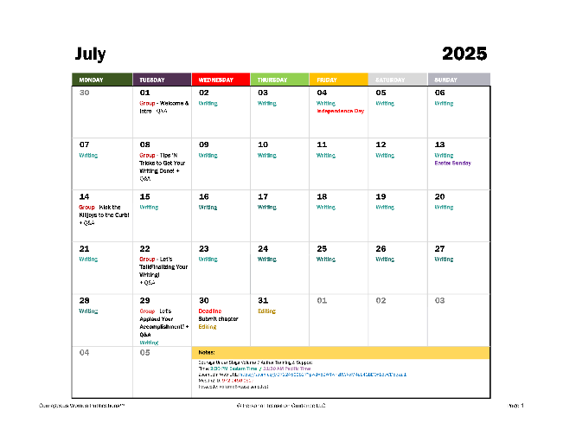
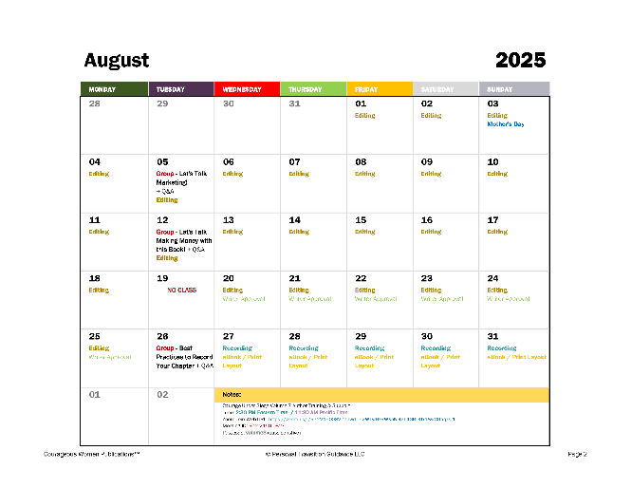
©2025 Personal Transition Guidance LLC & Courageous Women Publications™
Client Services Agreement
February 2025
PEGGYLEE HANSON

PAGE 2

BOOK PRODUCTION, PUBLISHING PHASES, TIMELINE, continued
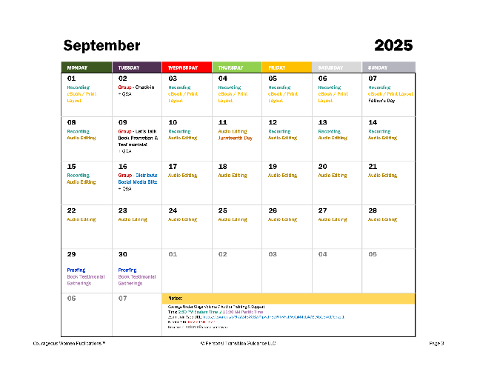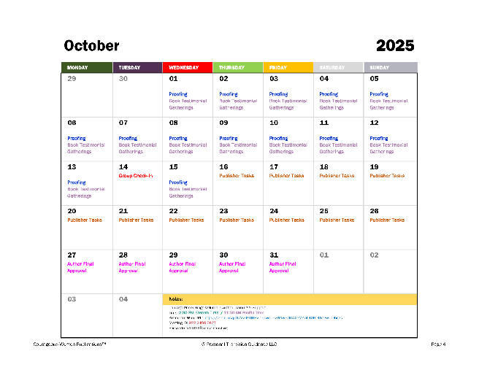

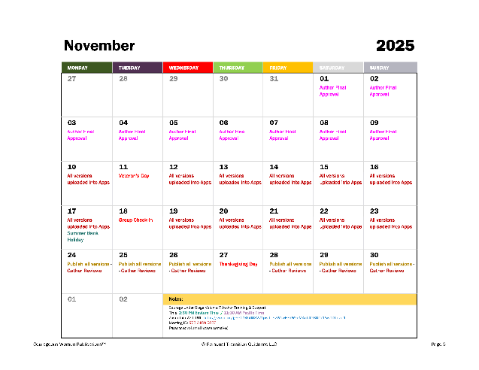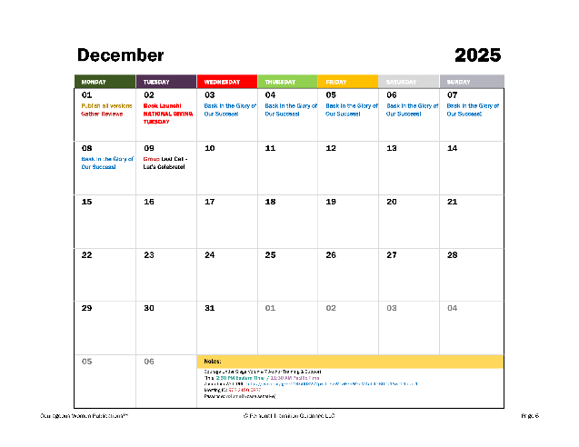

PAYMENT, CONTRACT & OTHER INFORMATION
This agreement between PeggyLee Hanson (herein referred to as DEVELOPER) and the recipient of the email (CLIENT) whereby this agreement is attached, and formally begin upon receipt of participation through PayPal or other financial arrangement.
By completing any one of the PayPal transactions, CLIENT acknowledges and gives consent to be included in this book named, “Courage Under Siege” or similar. CLIENT understands that there is a limit of ten (10) contributors per anthology book. Once the number of submissions reaches ten (10), CLIENT will have a choice to either:
- be published as an individual ebook via Amazon’s Kindle Direct Publishing open-source application, or
- be held over for the next publication of "Courage Under Siege" anthology work.

©2025 Personal Transition Guidance LLC & Courageous Women Publications™
Client Services Agreement
February 2025
PEGGYLEE HANSON

PAGE 3

PAYMENT, CONTRACT & OTHER INFORMATION (continued)
CLIENT also understands that their story is to be set chronologically of when the program payment is received in full.
With regards to the payment schedule, if the multi-pay option is selected, monthly payments are due the same day of each month as the first installment payment date. In the event subsequent payment cannot be rendered, CLIENT will inform DEVELOPER five (5) calendar days prior to when payment is due.
This contract is a flexible agreement between DEVELOPER and CLIENT. Changes to the delivery or payment schedule, terms, or any unforeseen circumstances during the project will be taken into consideration, should they occur. A resolution will be discussed and mutually agreed upon before any action is applied.

CANCELLATION FEES & PROJECT POLICY
If either party cancels the project, for any reason, a resolution will be discussed. An agreement will be reached to satisfy both CLIENT and DEVELOPER.

RIGHTS, COPYRIGHT & OWNERSHIP
The chapter submission and author profile materials created during the development of this project by CLIENT will become and are the sole proprietorship of CLIENT. No CLIENT will use any part of another client’s submission without prior permission. However, CLIENT immediately gives DEVELOPER permission to use excerpts at will for the purpose of marketing and promotional efforts.
The book copyright in its entire entity is assigned to DEVELOPER. DEVELOPER will also retain files for the sole purpose of back-up and not for public distribution or use on a project for another client.

CLIENT RESPONSIBILITIES
CLIENT agrees to:
  - Be present each week during training calls. If unable to attend, CLIENT will notify DEVELOPER of absence.
  - Open and read emails sent during production of this book, as they may contain important project information.
  - Participate in collaboration with marketing and promotional efforts.
  - Be of support and encouragement for the other anthology authors within this book.
  - Meet material submission requirements and deadlines.
  - Be willing to try methods foreign or new, such as Facebook Livestream, Zoom video conference meetings, and other social mediums.
  - Offer any assistance to FREELANCER in the form of editing, cover creation, proofing, any task to ensure the highest quality product.
  - Do your finest to help reach #1 BestSeller status on Amazon

©2025 Personal Transition Guidance LLC & Courageous Women Publications™
Client Services Agreement
February 2025
PEGGYLEE HANSON

PAGE 4

DEVELOPER RESPONSIBILITIES
DEVELOPER agrees to:
- Be on schedule pertaining to:
  - meeting times and duration
  - deadlines
- Be respectful of you and your work.
- Coach you through any uncertainty with your writing.
- Keep you on track to meet submission deadlines.
- Support you in every manner.
- Keep you informed with up-to-the-minute information as warranted.
- Produce a high-quality product.
- Make the process fun and as stress-free as possible.
- Teach you by example how to publish your own book.
- Do her finest to help you reach #1 BestSeller status on Amazon.

AGREEMENT ACKNOWLEDGMENT
By entering this business relationship through financial remittance, CLIENT agrees to the terms herein.

